Español IIIH Estudiante: ___________________________

Cap. 5.1: Las Artes Plásticas y la Arquitectura

PRESENTACIÓN



Look for an example of one of the following:



Cap. 5.1

**Art architecture photography sculpture**

Bring to class and be ready to talk about it for up to one minute. (45-60 seconds)

**Grammar: Focus on: passive se , passive voice with ser, comparisons/superlatives.**

Include: what it is: describe it – modern, classical, surrealist, realist, etc..; by whom (say something of the artist), where it is/ can be seen, why it is interesting to you, compare it to other works- by either other artists of the same category ( architect –architect), style, period of time, etc.

Add any other information you think is relevant.

[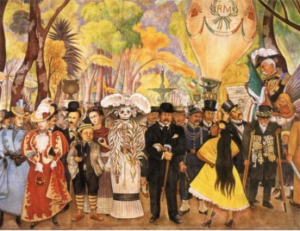](http://www.google.com/url?sa=i&rct=j&q=&esrc=s&frm=1&source=images&cd=&cad=rja&docid=2GlJf_lPJnpPIM&tbnid=jXZIc6ahUNUycM:&ved=0CAUQjRw&url=http://www.conservapedia.com/Diego_Rivera&ei=_MliUbGZHMLi0gGYiYCABg&bvm=bv.44770516,d.dmQ&psig=AFQjCNFrhOq_0wBdmGH8Sa5qHdnCdMYz3Q&ust=1365515122235308)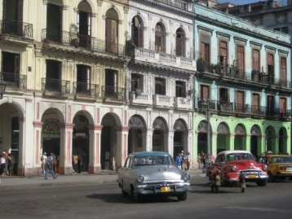[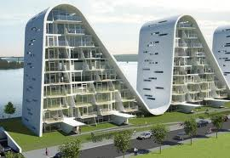](http://www.google.com/imgres?hl=en&biw=1247&bih=662&tbm=isch&tbnid=a0_iybnQio672M:&imgrefurl=http://stlhandmade.blogspot.com/2012/06/perfect-modern-architecture-design.html&docid=nKveQZWJpXNzEM&imgurl=http://4.bp.blogspot.com/-4EGrrve4QkI/Tie8kL5eVXI/AAAAAAAAB-8/QbjGN240Az8/s1600/Perfect%2BModern%2BArchitecture%2BDesign.jpg&w=580&h=400&ei=oMpiUa3zEsnp0gGqoICYAg&zoom=1&ved=1t:3588,r:20,s:0,i:221&iact=rc&dur=454&page=2&tbnh=182&tbnw=265&start=15&ndsp=20&tx=106&ty=82)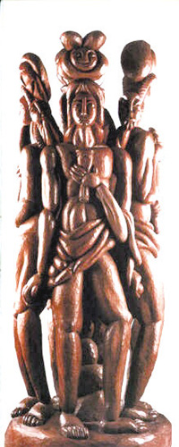

-Find a work of art in a category that interests you (preferably from a spanish speaking country),

take notes keeping in mind the requirements of this assignment.

Nombre de la obra: ____________________________________________

Tipo de obra: _____________________________________________

Estilo: _____________________________________________

Autor: _____________________________________________

Descripción: _____________________________________________

_____________________________________________

Opinión personal: _____________________________________________

_____________________________________________

Comparación: _____________________________________________

_____________________________________________

Donde se puede ver?: _____________________________________________

* Now write a paragraph including the information above. You will need a print out of the artwork that you are talking about- up to 8 ½ x 11 to show the class.

_________________________________________________________________________________

_________________________________________________________________________________

_________________________________________________________________________________

_________________________________________________________________________________

_________________________________________________________________________________

_________________________________________________________________________________

_________________________________________________________________________________

_________________________________________________________________________________

_________________________________________________________________________________

_________________________________________________________________________________

_________________________________________________________________________________