MI CASA IDEAL
Proyecto capítulo 2
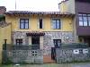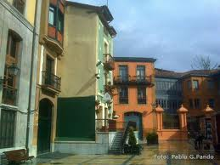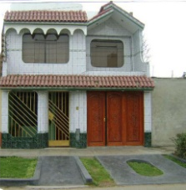
Objetivo: You need to design and furnish your ideal home. Create a book or poster showing the different rooms of your new home: the kitchen, living room, bathroom, bedroom, and dining room. You also need to include 3 items in each room. (No repeats.)
Para:_________________________________ Vale un examen
No rúbrica = -3 Tarde: -5 puntos cada día
We only have two days in the lab so make sure you print out and/or save your information. We will have time in class on ______________ and ______________ to work on this.

Requirements: You will create a book or poster with your house plans.

1. La Parte Escrita:
Write a paragraph which includes the following information:
- Where your house is
- How many floors it has.
- Describe each room. (In the ____, there is ____, ____ and ______).
- Describe where 1 item is located (per room) in reference to something else. (Estar + prepositions) Use 5 different prepositions in total.
- Say one chore that one has to do in each room. (use expressions: hay que, tener que, haz el favor de, etc..) Mention 5 different chores in total.
- Say a complaint about the chores for 3 of the rooms

2, La Parte Visual:
- Create a book or a poster showing your ideal house and furniture.
- Include a picture for each room. Clearly label what the room is. You picture must correspond to your written description.
- Neatly label a minimum of 3 items in each room. No repeats between rooms!
- Use ink, not pencil.
- If you make a book, include a cover page with the title “mi casa ideal” and an appropriate heading.
La rúbrica- Mi casa ideal
La Parte Escrita:
Spelling/accents ________ 10
Grammar ________ 20
Vocabulary ________ 10
All requirements met ________ 10

La Parte Visual:
5 clearly labeled pictures of each room ________ 15
3 items in each room (no repeats) ________ 15
Spelling/accents ________ 10
Neat/shows effort & creativity ________ 10

Late day ________ -5 each
No rubric ________ -3

Total __________

