Vocab 1, expressions 1

Adverbs

Double object pronouns

Commands

Vocab 2, expressions 2

Past participles

***The study guide is in order of the above***

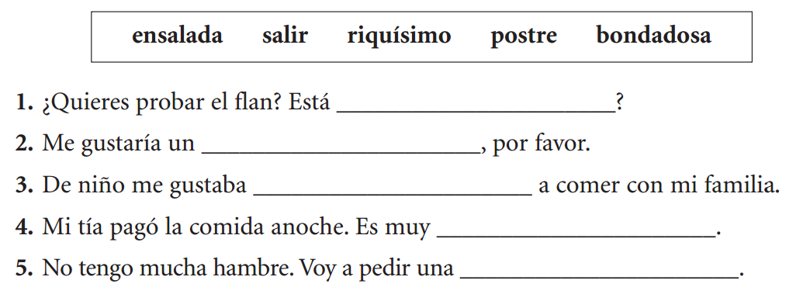

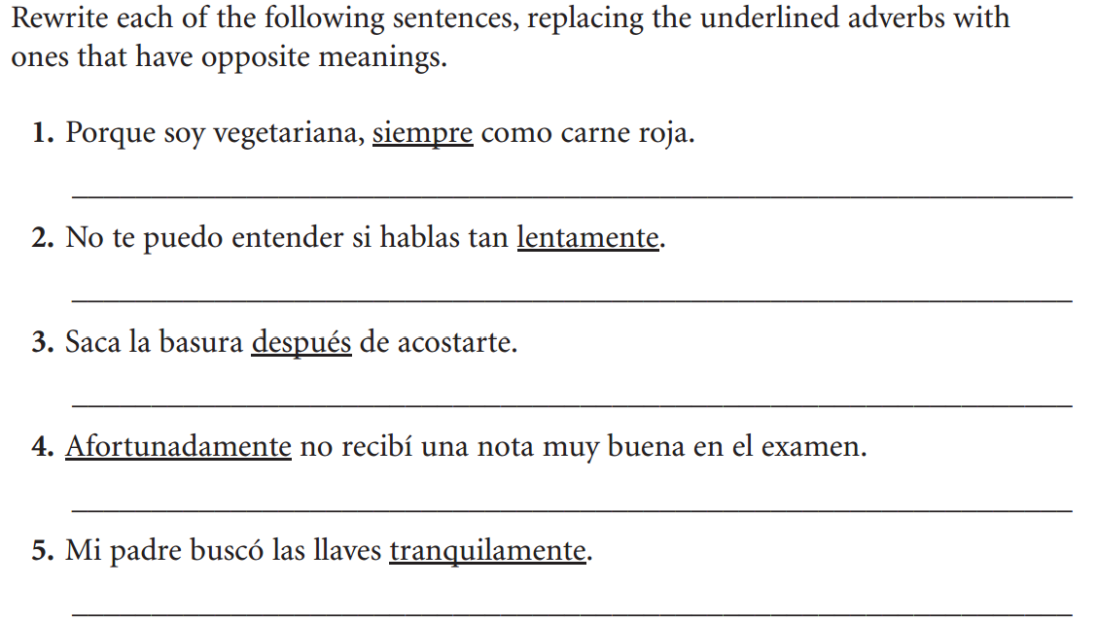

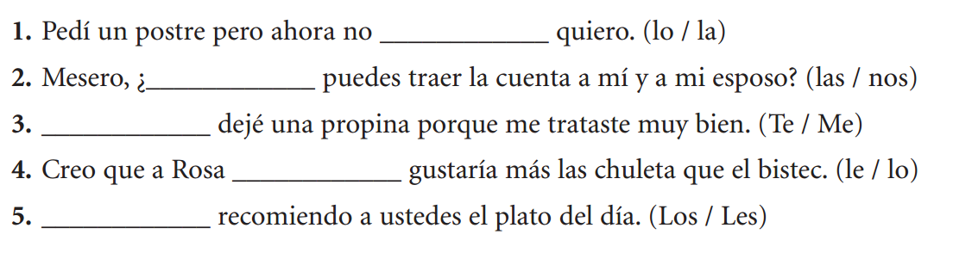

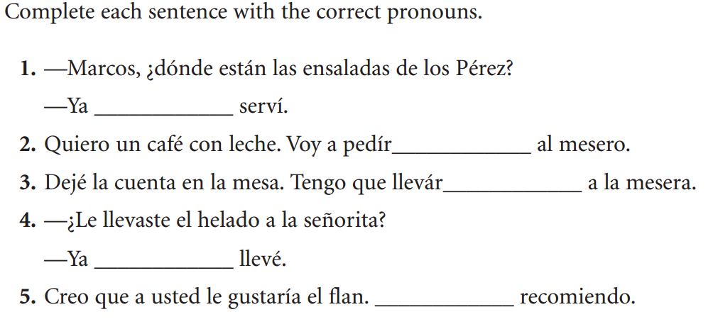

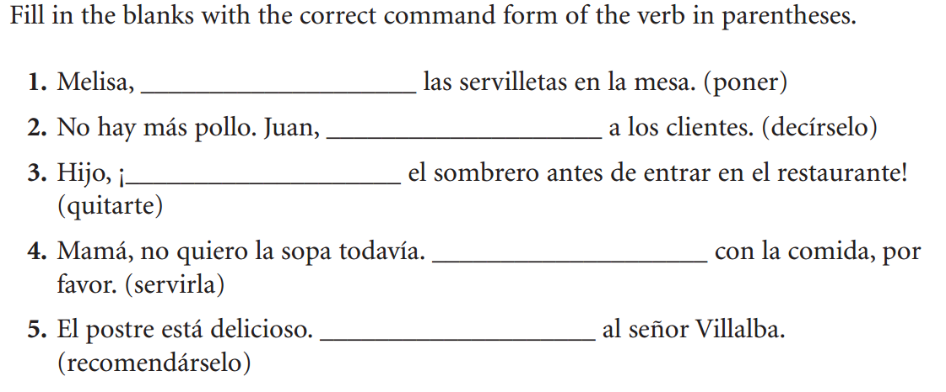

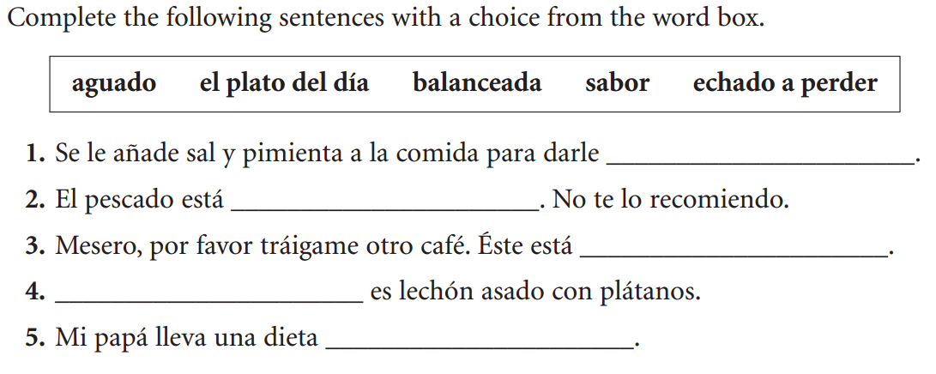

**Turn the following verbs into past participles.** –ar 🡪 ado/a and –er/-ir 🡪 ido

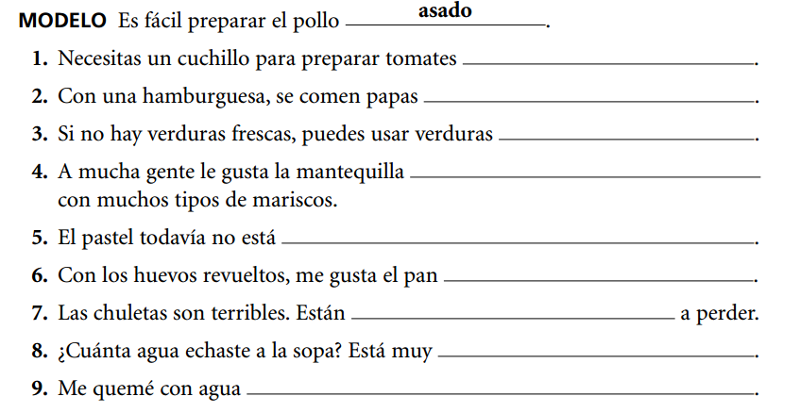

**(echar)**

**(hervir)**

**(aguar)**

**(tostar)**

**(hornear)**

**(cocer)**

**(derretir)**

**(freir)**

**(picar)**

**(asar)**

